How to get data onto the Data Dashboard

For collecting data in the classroom with the WeatherSat connected directly to the internet follow these instructions.

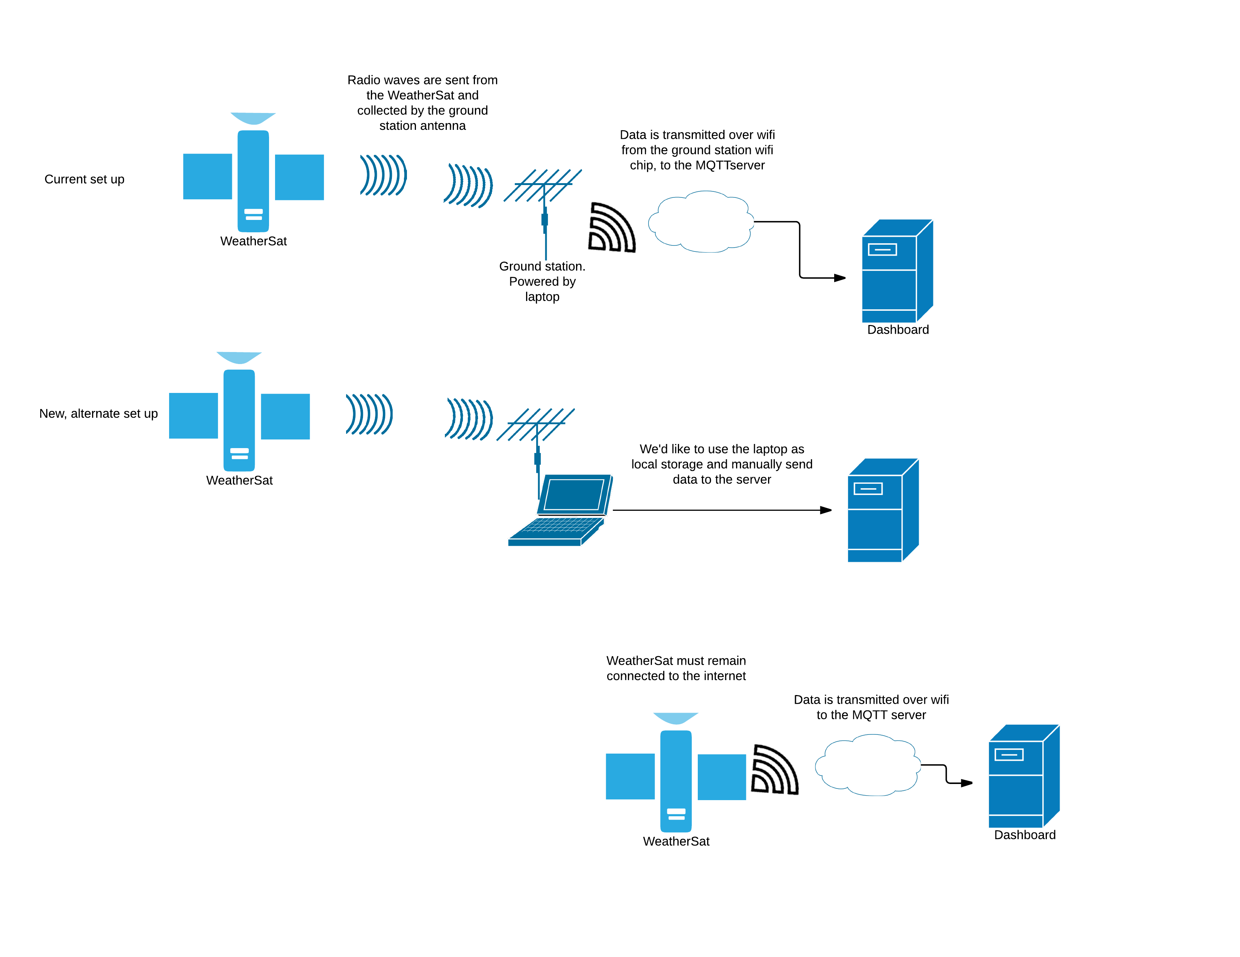

Sometimes you want to collected data remotely without your WeatherSat being directly connected to the internet (such as during the balloon launch). In these cases, you will use the Radio Modules (CR03) and a Ground Station. As long as the radio modules are in range of each other, you can get data to the Dashboard.

